1.Memory Transfer Program

ORG 0000H
MOV R0,#30H
MOV R1,#40H
MOV R7,#05H
BACK:MOV A,@R0
MOV @R1,A
INC R0
INC R1
DJNZ R7,BACK
END

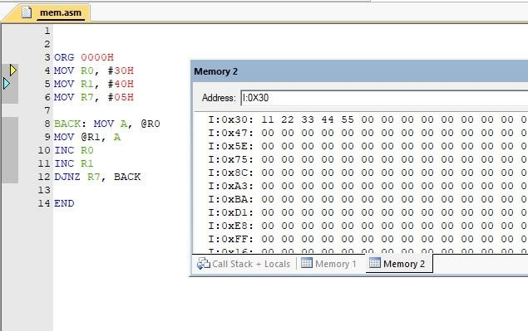

2.Parallel port interfacing of LED’S

#include <reg.51h>
void delay (unsigned int X){
int i;
for (i=0;i<X;i++)
}
void main(){
while(1){
P1=~P1;
delay(1000);
}
}

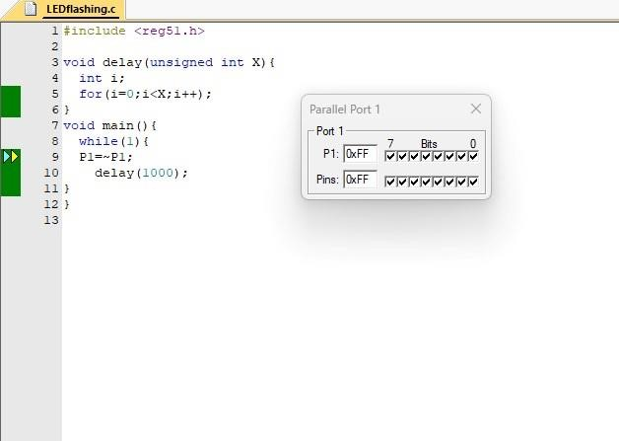

3.Square wave generation using timer with interrupt

#include <reg51.h>
sbit square_wave_pin = P1^0;
void delay(){
int i, j;
for(i=0;i<100;i++)
for(j=0;j<1275;j++);
}
void main(){
while(1){
square_wave_pin=1;
delay();
square_wave_pin=0;
delay();
}
}
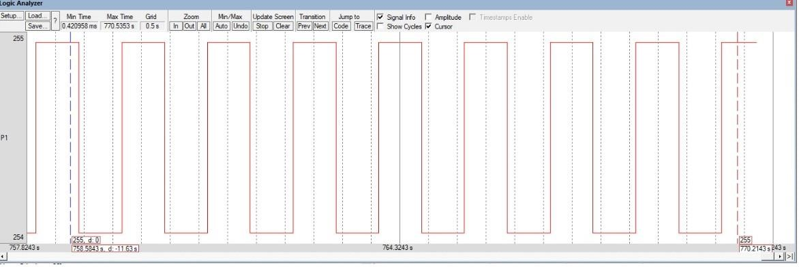

Experiment 1:
8bit addition –
ORG 0000H
MOV A, #03H
MOV B, #03H
ADD A, B
END

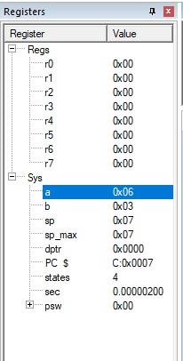

16 bit addition
;First 16-bit number: 3456H
;Second 16-bit number: 4567H
ORG 0000H
;LSB Addition
MOV A, #56H
MOV B, #67H
ADD A, B
MOV R0, A
;MSB Addition
MOV A, #34H
MOV B, #45H
ADDC A,B
MOV R1, A
END

Experiment 2.
8bit Subtraction-
ORG 0000H
MOV A, #05H
MOV B, #03H
SUBB A, B
END
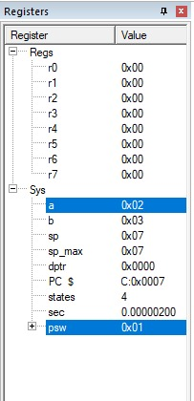

16 bit substraction
ORG 0000H
CLR C
; LSB Subtraction
MOV A, #65H
MOV B, #12H
SUBB A,B
MOV R6 ,A
;MSB Subtraction
MOV A, #57H
MOV B, #23H
SUBB A,B
MOV R3,A
END

Multiplication of 8 bit:
ORG 0000H
MOV A, #02H
MOV B, #02H
MUL AB
END

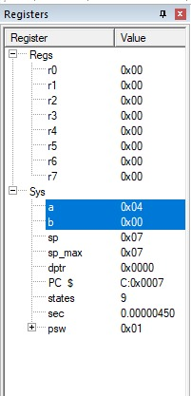

Division of 8 bit:
ORG 0000H
MOV A, #08H
MOV B, #02H
DIV AB
END
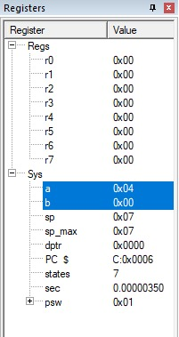

Experiment 3. Parallel Port LED Interfacing (ALL LEDS):
#include <reg51.h>
//delay function declaration
void delay(void);
void main(void)
{
//an infinite loop
while(1)
{
// Turn ON all LED's connected to Port1
P1 = 0xFF;
delay();
// Turn OFF all LED's connected to Port1
P1 = 0x00;
delay();
}
}
//delay function definition
void delay(void)
{
int i,j;
for(i=0;i<0xff;i++)
for(j=0;j<0xff;j++);
}
Experiment 4. Parallel Port LED Interfacing (ALternate LEDS):

#include <reg51.h>

void DELAY_ms(unsigned int ms_Count)
{
unsigned int i, j;
for (i = 0; i < ms_Count; i++)
{
for (j = 0; j < 100; j++); // Note: The inner loop bound is unclear, assumed to be a small value for demonstration
}
}

int main()
{
while (1)
{
P2 = 0xAA; // Set P2 to 1010 1010b
DELAY_ms(500); // Delay 500ms

P2 = 0x55; // Set P2 to 0101 0101b
DELAY_ms(500); // Delay 500ms
}
return (0);
}
Experiment 5. Seven Segment Display

#include <reg51.h>

// Define the segment values for numbers 0-9
unsigned char seg_code[10] = {
0x3F, // 0
0x06, // 1
0x5B, // 2
0x4F, // 3
0x66, // 4
0x6D, // 5
0x7D, // 6
0x07, // 7
0x7F, // 8
0x6F // 9
};

void delay(unsigned int ms) {
while (ms--) {
unsigned int i;
for (i = 0; i < 123; i++); // Roughly 1 ms delay
}
}

void display(unsigned char num) {
P1 = seg_code[num]; // Send the segment code to port P1
}

void main() {
unsigned char i;

while (1) {
for (i = 0; i < 10; i++) {
display(i); // Display numbers 0-9
delay(1000); // Delay for 1 second
}
}
}
Experiment 6.Switch ,Relay and Buzzer
#include <reg51.h>

sbit Buzzer = P3^7;
void delay_ms(unsigned int time) //This Function is used to cause delay between LED ON and OFF events
{
unsigned int i, j;
for (j=0; j<time; j++)
for(i=0; i<113; i++);
}

void Ext_Int1 (void) interrupt 2 //0013h
{
Buzzer = ~Buzzer;
delay_ms(250);
}

void main() //the program execution stat point//
{
Buzzer = 1;
INT1 = 1;
EX1 = 1;
EA = 1;
while(1);
}
LCD DISPLAY:
#include <reg51.h>

//Declarations
#define LCD_DATA P2 //LCD data port to PORTD

sbit rs = P0^0;
sbit rw = P0^1;
sbit en = P0^2;

//Function Prototypes
void init_LCD(void); //Function to initialize the LCD
void LCD_command(unsigned char cmd); //Function to pass command to the LCD
void LCD_data(unsigned char val); //Function to write character to the LCD
void LCD_write_string(char *str);//Function to write string to the LCD
void msdelay (unsigned int time); //Function to generate delay

//Start of Main Program
void main(void)
{
char var1[] = "LCD Interface";//Declare message to be displayed
char var2[] = "Test Program";

init_LCD(); // call function to initialise of LCD
msdelay(50); // delay of 50 mili seconds

LCD_write_string(var1);//Display message on first line
msdelay(15);

LCD_command(0xC0); // initiate cursor to second line
LCD_write_string(var2);//Display message on second line

while (1); //Loop here
} //End of Main

//Function Definitions
void msdelay (unsigned int time) //Function to generate delay
{
unsigned int i, j;
for (i = 0; i < time; i++)
for (j = 0; j < 113; j++);//Calibrated for a 1 ms delay in MPLAB
}

void init_LCD(void) // Function to initialise the LCD
{
LCD_command(0x38); // initialization of 16X2 LCD in 8bit mode
msdelay(15);
LCD_command(0x01); // clear LCD
msdelay(15);
LCD_command(0x0C); // cursor off
msdelay(15);
LCD_command(0x80); // go to first line and 0th position
msdelay(15);
}

void LCD_command(unsigned char cmd) //Function to pass command to the LCD
{
LCD_DATA = cmd; //Send data on LCD data bus
rs = 0; //RS = 0 since command to LCD
rw = 0; //RW = 0 since writing to LCD
en = 1; //Generate High to low pulse on EN
msdelay(15);
en = 0;
}

void LCD_data(unsigned char val)//Function to write data to the LCD
{
LCD_DATA = val; //Send data on LCD data bus
rs = 1; //RS = 1 since data to LCD
rw = 0; //RW = 0 since writing to LCD
en = 1; //Generate High to low pulse on EN
msdelay(15);
en = 0;
}
//Function to write string to LCD
void LCD_write_string( char *str)
{
int i = 0;
while (str[i] != 0)
{
LCD_data(str[i]); // sending data on LCD byte by byte
msdelay(15);
i++;
}
}

